1.Host a Ubuntu Virtual Machine using Oracle VM Virtual Box.

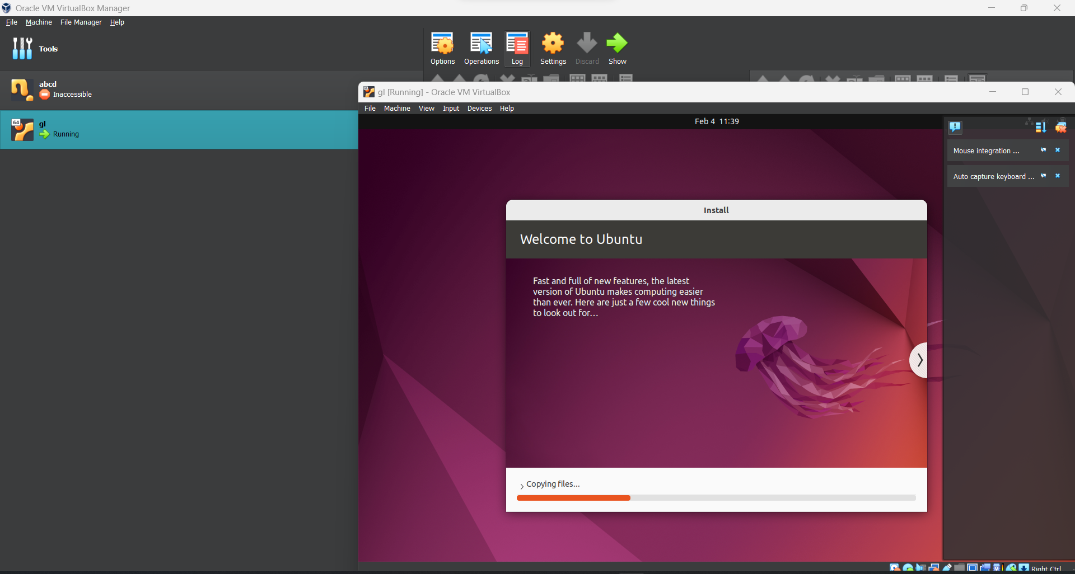

2.Setup VSCode on Ubuntu VM.

a) Make vboxuer a sudoer:

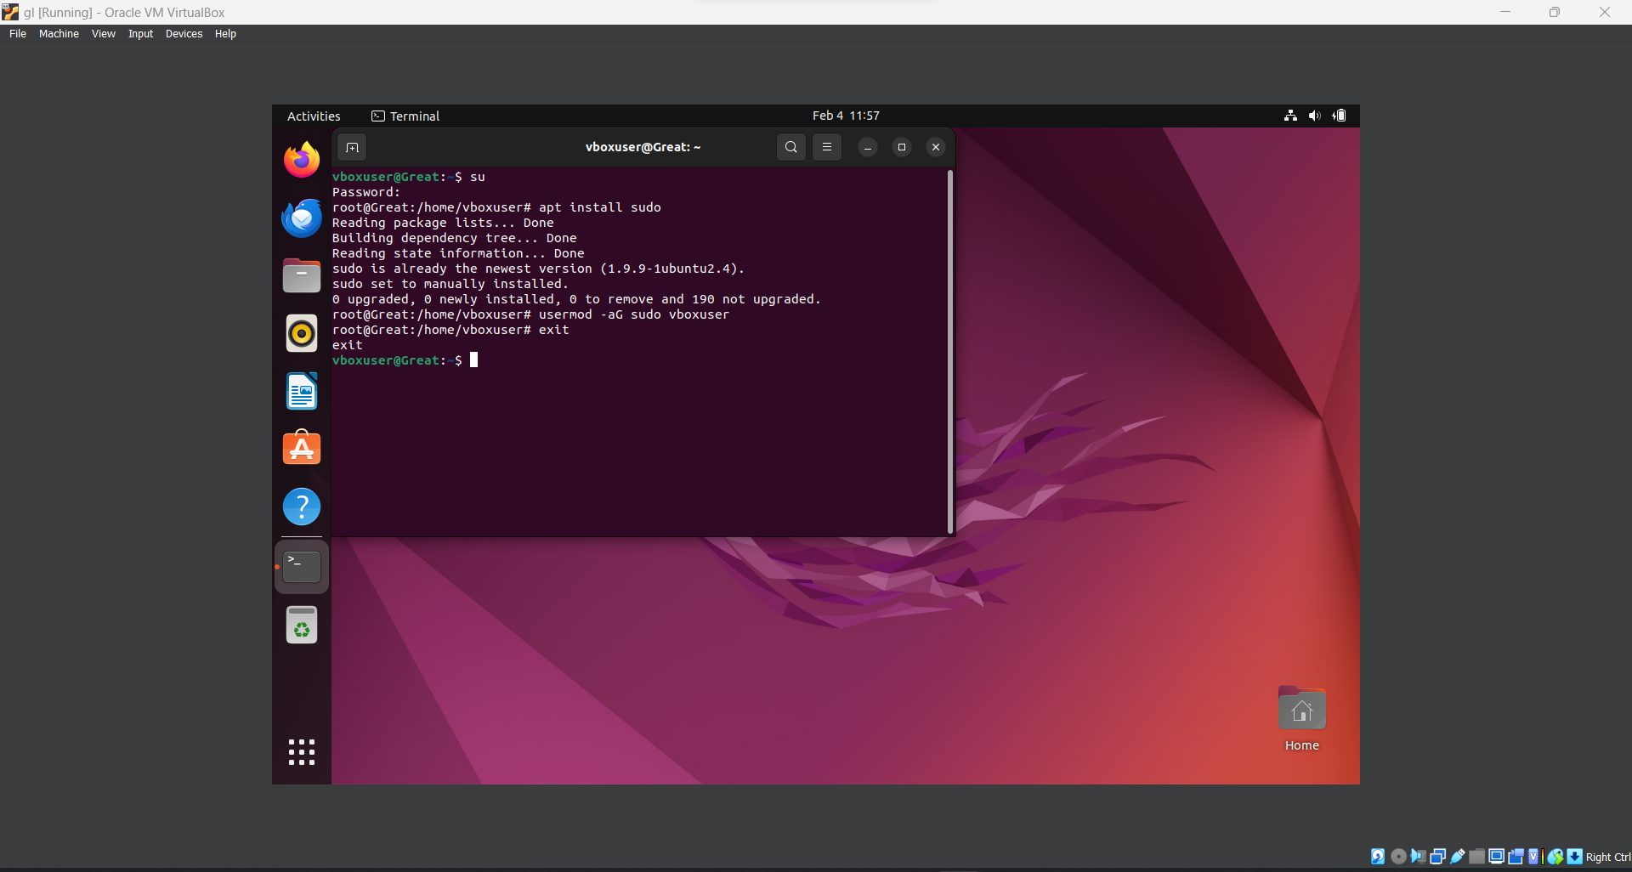

b) Install .deb file from VSCode

c) sudo apt install ./<file>.deb

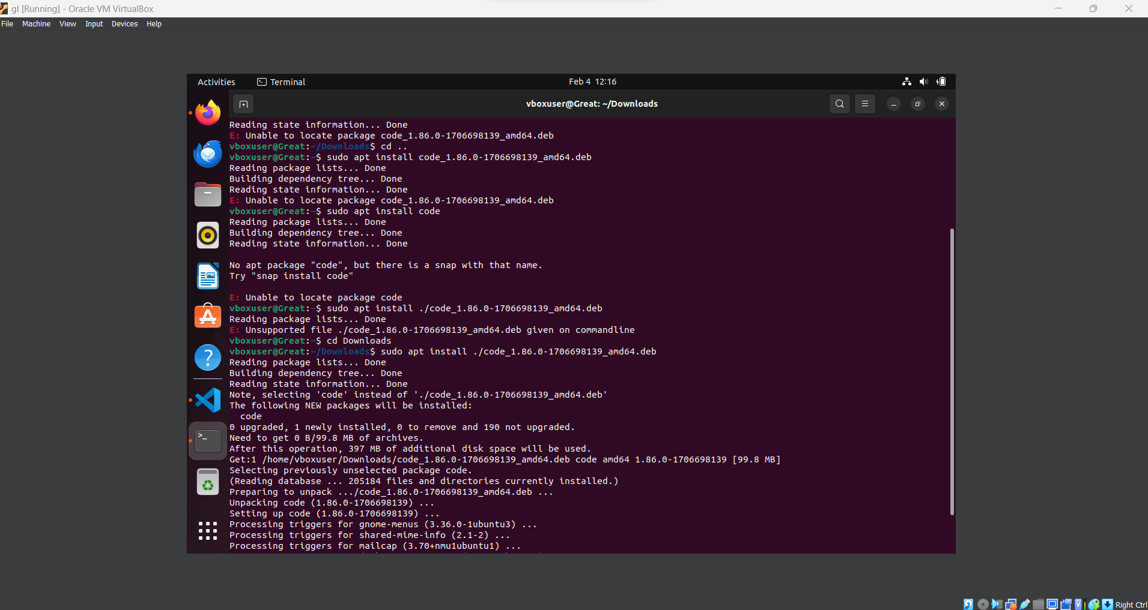

3) STEPS 3,4, and 5:

a) Create a virtual environment with python and activate the virtual environment using:

sudo pip3 install virtualenv

sudo apt install python3.10-venv

python3 –m venv gl

cd gl

source bin/activate

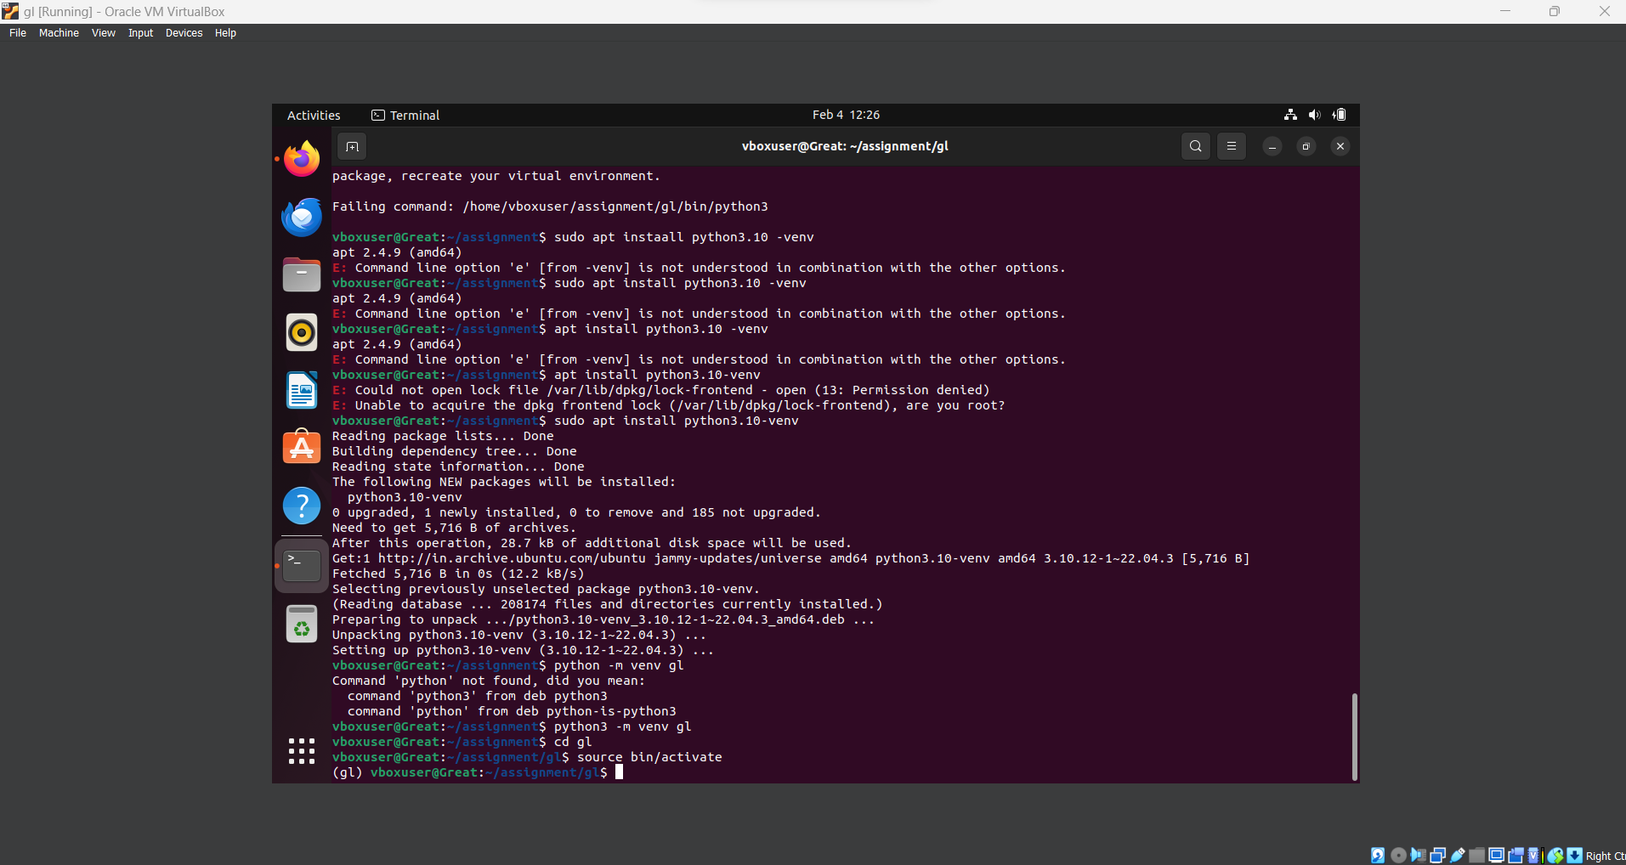

b) Open VSCode, download Git for Linux and clone the mentioned repository using:

code

sudo apt-get install git

(In VSCode) - > Click on Clone Reporsitory

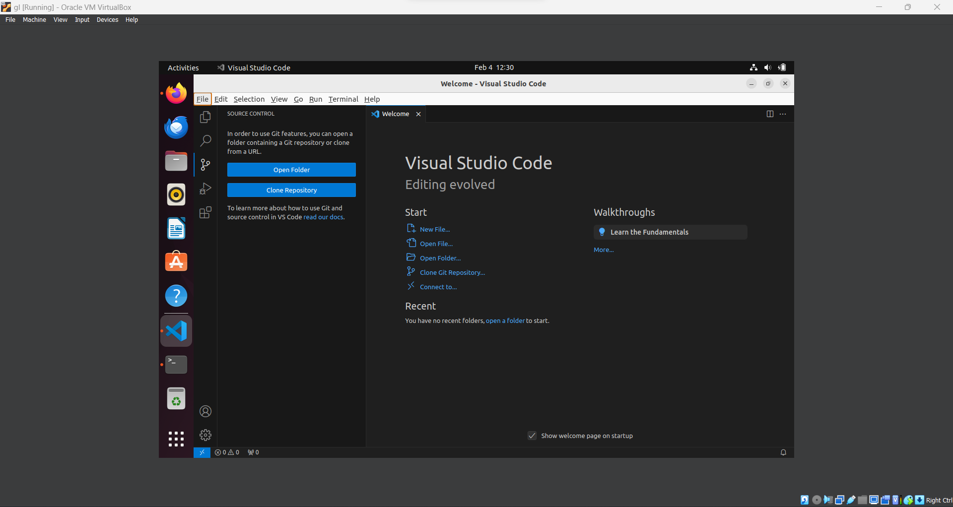

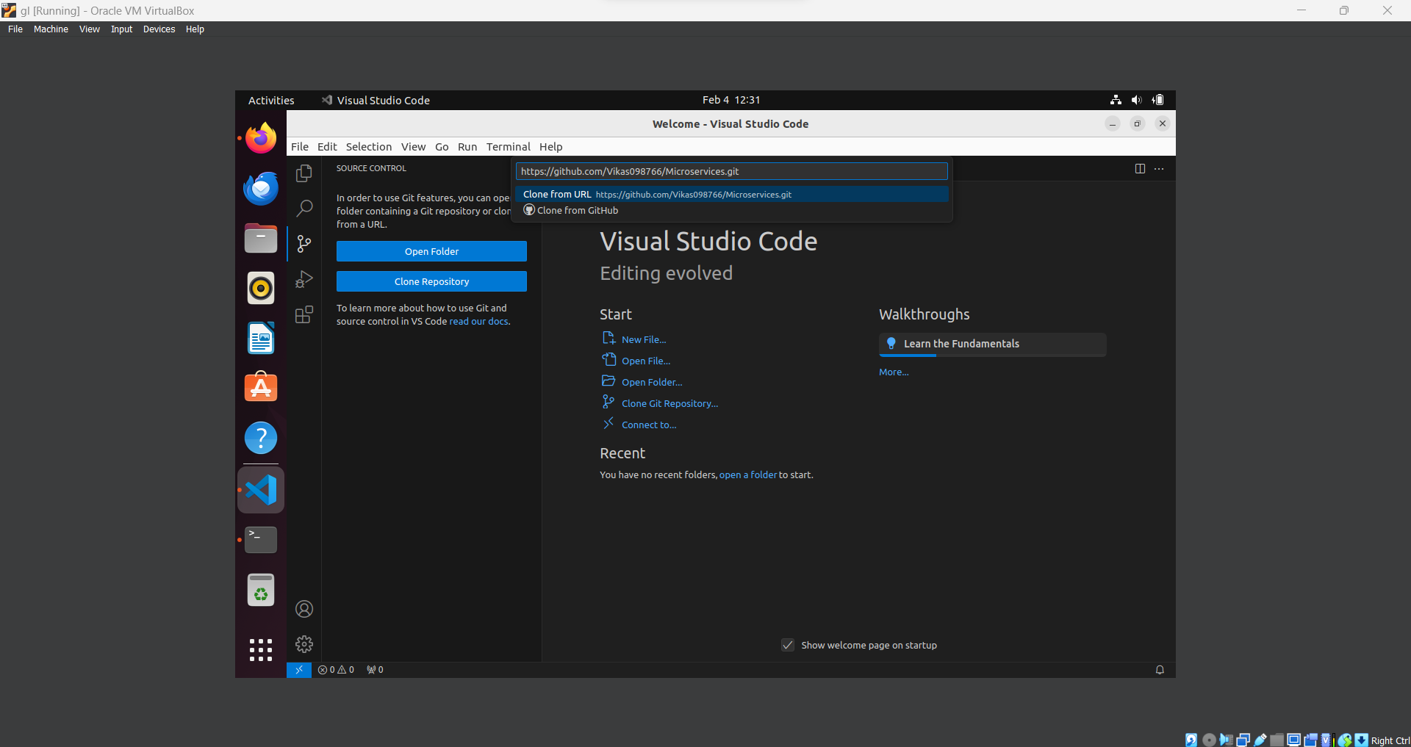

Now select the folder which has the environment which has created and place the clone repository there.

6. Install all the dependencies from the reuirements.txt file using:

cd Microservices

pip install –r requirements.txt

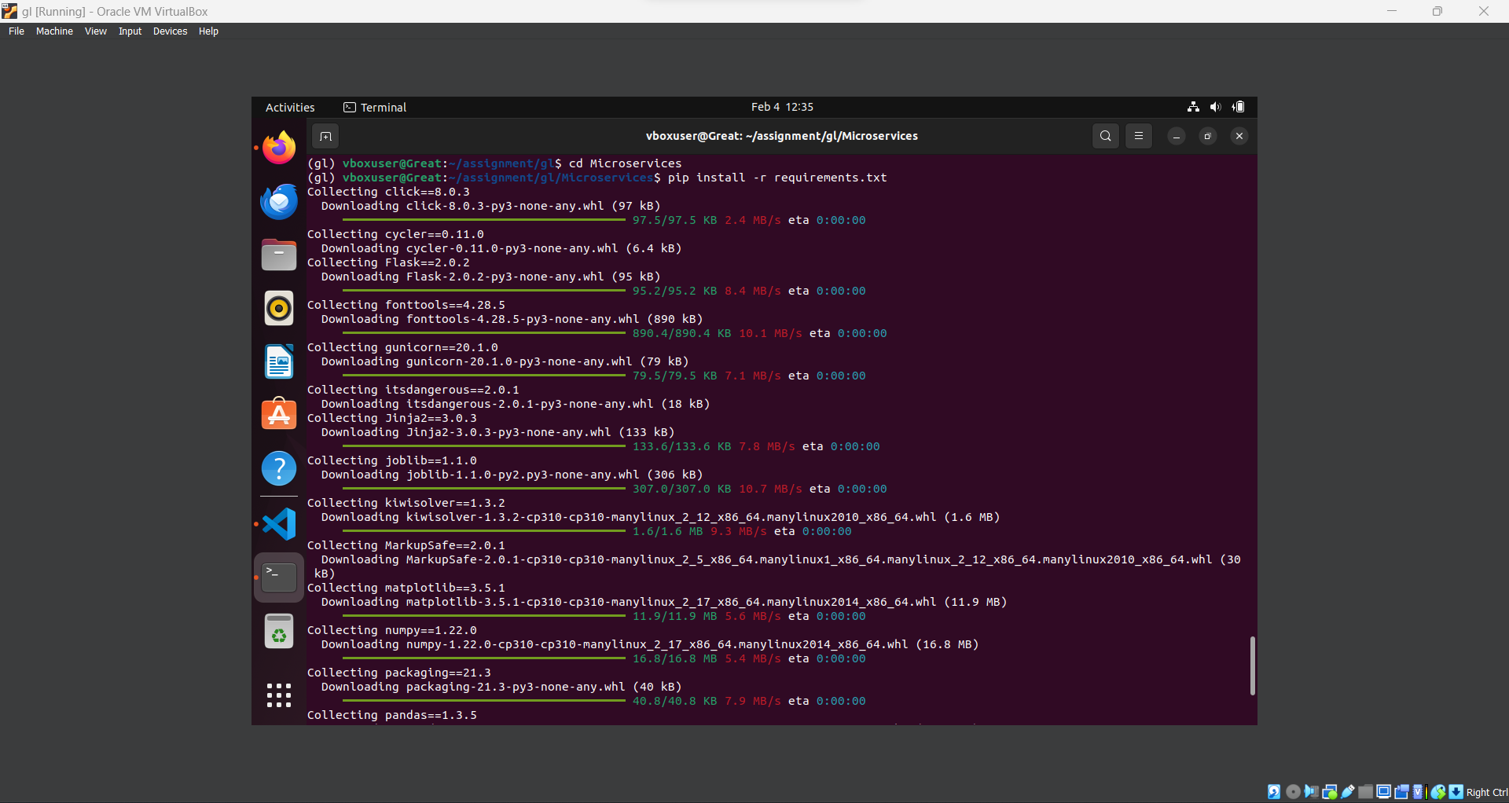

7. Train and save the model using:

python code_model_training/train.py



8. Test the Flask Web Application using:

python app.py

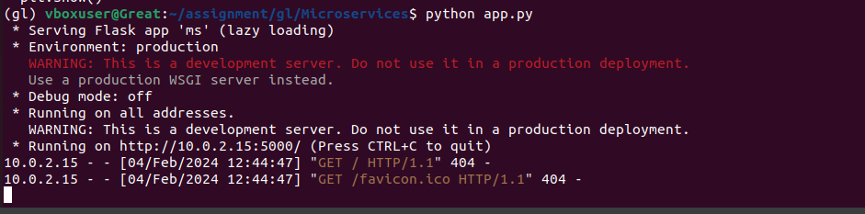

9. Test the application and make predictions using the example calls available in the folder /tests.

a) Write a file test_request.py, through which we can call /predict, /info and /health

1. Info
2. /info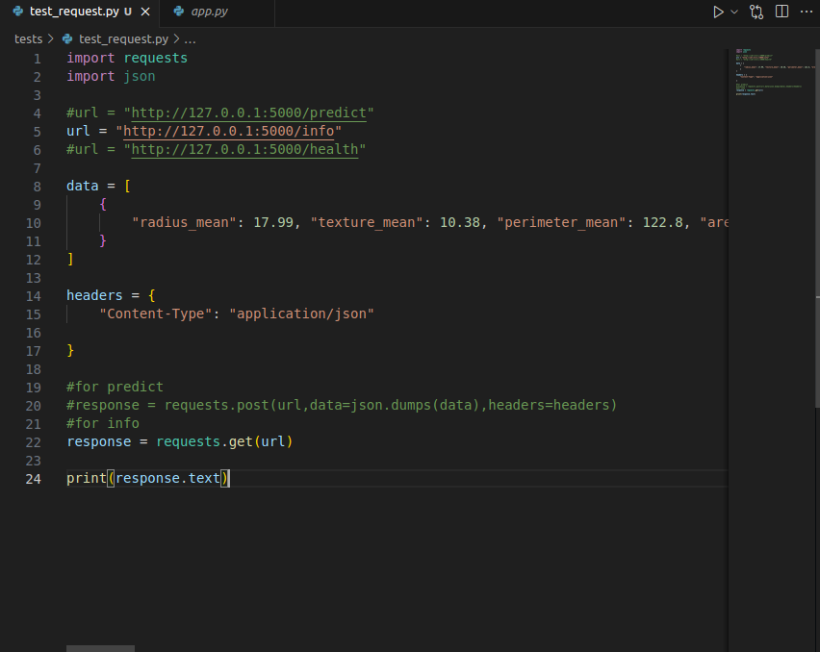

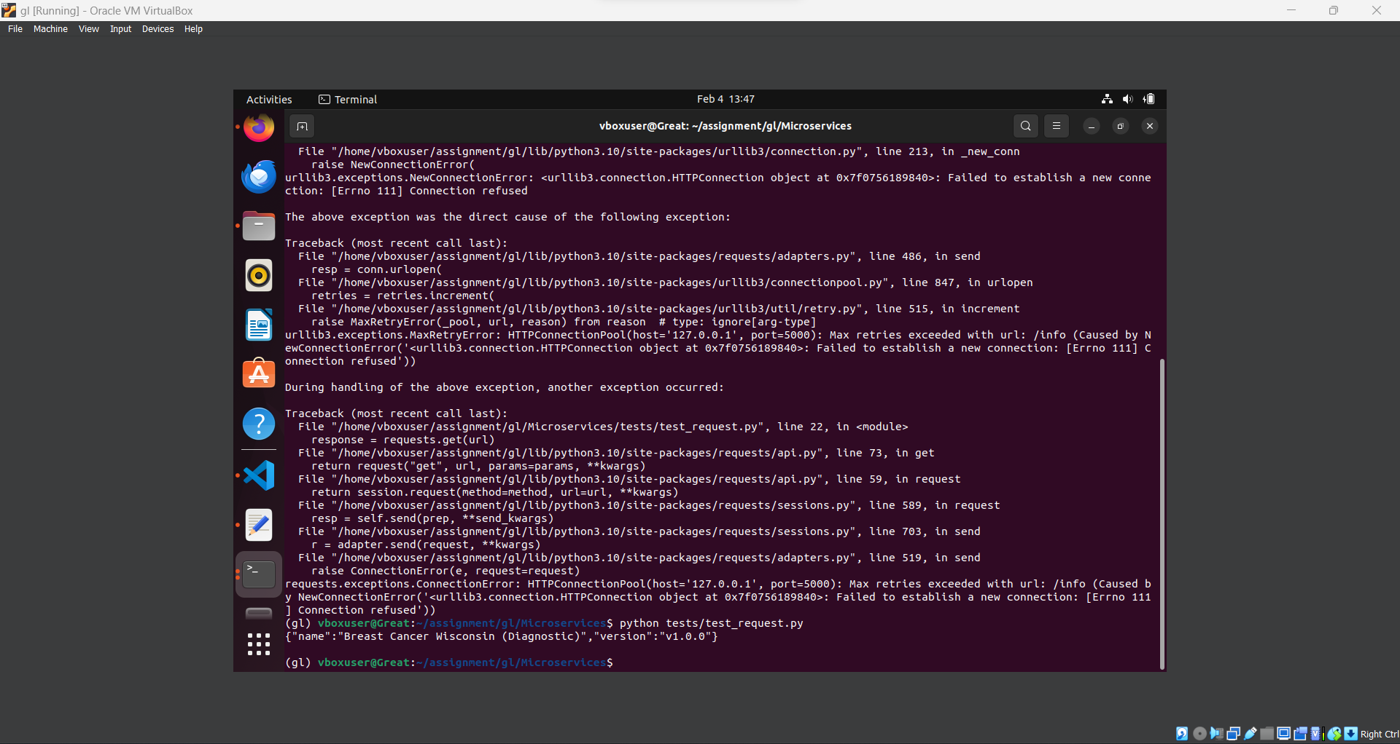

1. /health



1. /predict

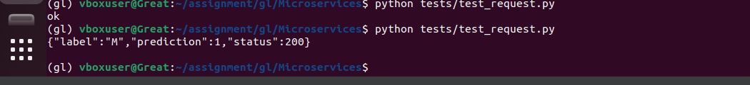

10. Create a docker image containing everything needed to run the application.

install docker with the respective commands and test it with this command:

sudo docker run hello-world:latest

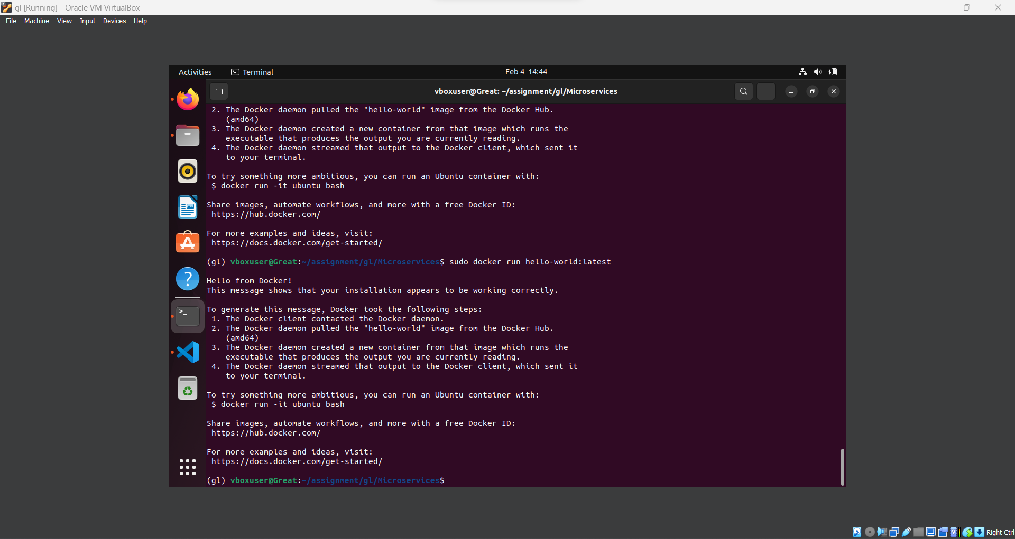

Build and run the docker image using:

1. Docker file with these lines:

FROM python:3.10.2 AS builder

WORKDIR .

RUN apt-get update && apt-get install -y \

build-essential \

curl \

software-properties-common \

git \

&& rm -rf /var/lib/apt/lists/*

COPY requirements.txt .

RUN pip install -r requirements.txt

COPY . .

EXPOSE 5000

CMD ["python", "app.py"]

b) Build the docker image with : sudo docker build –t app1:v5

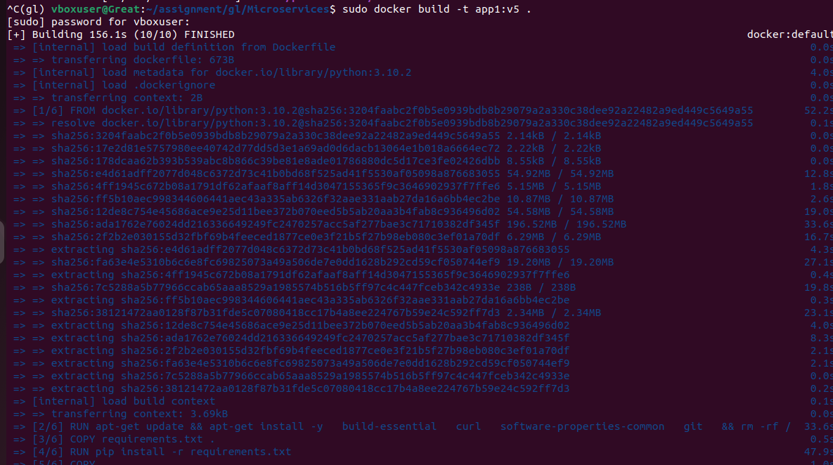

1. Run the docker image with: sudo docker run –p 5000:5000 app1:v5

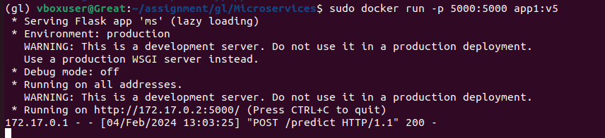

11. Run the containerized application as a prediction service and test it locally by passing some example calls and get the prediction.

python3 tests/test_request.py

/predict



Change the values

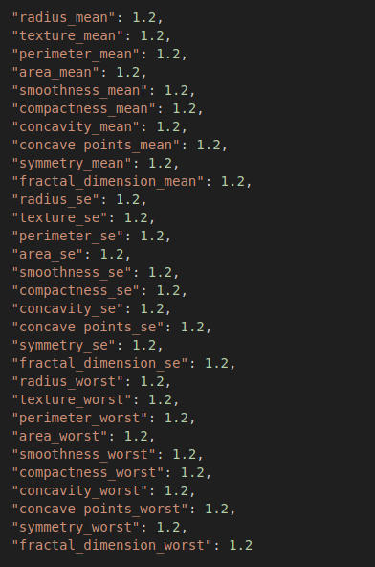

Predicting again:

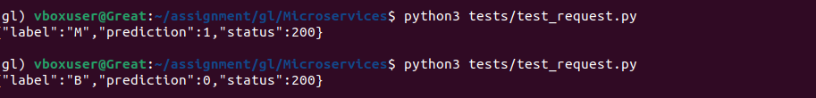

/info

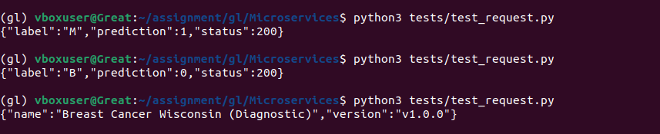

/health

